**Spatio-temporal variability in vine vigour and yield at the within-vineyard scale in a Marlborough Sauvignon Blanc vineyard**

Rob Bramley1, Jackie Ouzman1, Mike Trought2, Sue Neal2

*1CSIRO, Waite Campus, Locked Bag 2, Glen Osmond, SA 5064, Australia; 2New Zealand Plant and Food Research, Marlborough Wine Research Centre, PO Box 845, Blenheim, 7240, New Zealand.*

**Introduction**

The Marlborough wine region is centred on the active floodplains of the Wairau and Awatere rivers. Both are characterised by poorly developed sandy, gravelly and generally shallow soils, intersected by narrow sections of deeper and siltier soils corresponding to remnant drainage lines that have been in-filled following flooding. In the Wairau Valley, the silty hollows correspond to the Wairau soil series (Rae and Tozer, 1990) and run across the gravelly Rapaura series in an approximately east-west direction. Because the orientation of vine rows is predominantly north-south, complex patterns of vineyard variability result. Thus, Trought et al. (2008) and Bramley et al. (2011b) have shown that the resulting variation in soil depth, and especially in soil texture, has a marked impact on vine vigour, with the deeper siltier soils bearing more vigorous vines. In turn, this variation impacts on grape quality (Trought et al., 2008; Trought and Bramley, 2011).

Bramley et al. (2011b) used a combination of measures of trunk circumference, remote and proximal canopy sensing, electromagnetic soil survey at high spatial resolution and yield monitoring and mapping to examine variation in vine vigour and yield at the within-vineyard scale in a 5.9 ha Sauvignon Blanc vineyard on the north side of the Wairau plain; Trought et al. (2008) provide a detailed description of the site. Using remotely sensed digital multispectral video imagery (~ 50 cm on-ground resolution) obtained at veraison (Lamb et al., 2004) in each of two seasons (2006 and 2007), along with measures of trunk circumference made on 2,028 vines in 2004, and proximal sensing of the canopy from the side in 2007, Bramley et al. (2011b) inferred that patterns of variation in vine vigour were stable in time; the data analysed in this work were obtained over a period totalling four seasons (Figure 1). Note that trunk circumference is indicative of vine vigour over the life of the vine, whilst both remote and proximal sensing of the canopy give measures of instantaneous vine vigour (Bramley, 2010 and references therein). Bramley et al. (2011b) noted the close association between variation in vine vigour, elevation and apparent electrical soil conductivity (ECa) measured ‘on-the-go’ in 2001 using an ‘EM38’ electromagnetic soil sensor (Figure 2). In light of the results of Trought et al. (2008), this strongly suggested that variation in the ECa was related to variation in soil texture and depth (Mills 2006); that is, these high resolution spatial data lent weight to the close association between vine vigour and soil variation. However, Bramley et al. (2011b) found no association between soil variation and grape yield as measured using a yield monitor at harvest in 2006 (Figure 3), nor between vine vigour and yield. This latter result was in marked contrast to what has commonly been observed in most other studies of within-vineyard variation (e.g. Bramley and Hamilton, 2007; Bramley, 2010 and references therein; Bramley et al., 2011a). However, whereas these other studies have predominantly been carried out in mechanically spur-pruned Australian vineyards, the Marlborough vineyard studied by Trought et al. (2008), Bramley et al. (2011b) and Trought and Bramley (2011), like most vineyards in New Zealand, is cane pruned by hand. Bramley et al. (2011b) speculated that a possible explanation for the disassociation between grape yield and vine vigour in Marlborough was that the careful selection of similar canes for retention at pruning

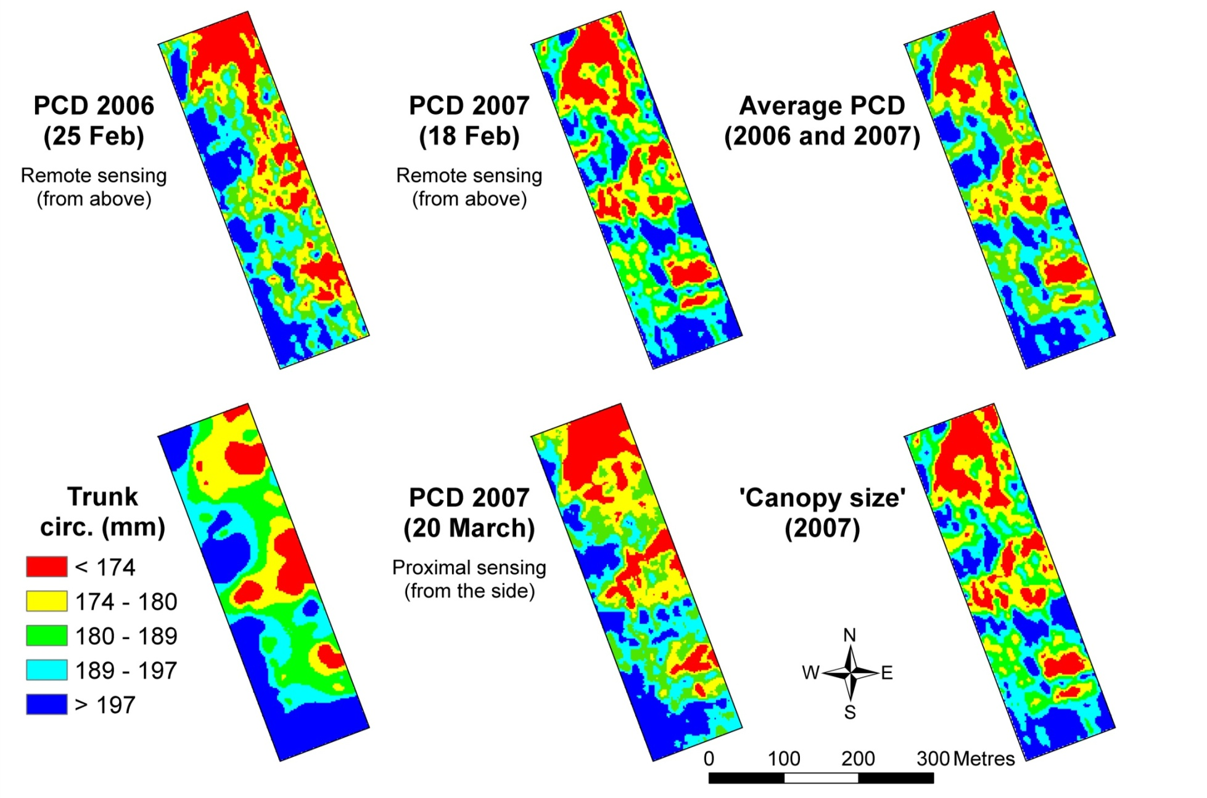

**Figure 1.** Variation in a range of indices of vine vigour in ‘Squire D’, 2004-2007. ‘Plant cell density’ (PCD) is the ratio of infrared:red reflectance. ‘Canopy size’ was calculated by multiplying the normalised 2007 remotely sensed image with the image obtained from the Crop Circle™ sensor (proximal sensing). Trunk circ. denotes the trunk circumference measured in 2004. Note that in all maps, the legend categories represent 20th percentiles. In all cases, red denotes the bottom 20th percentile. Data of Bramley et al. (2011b) who provide further detail.

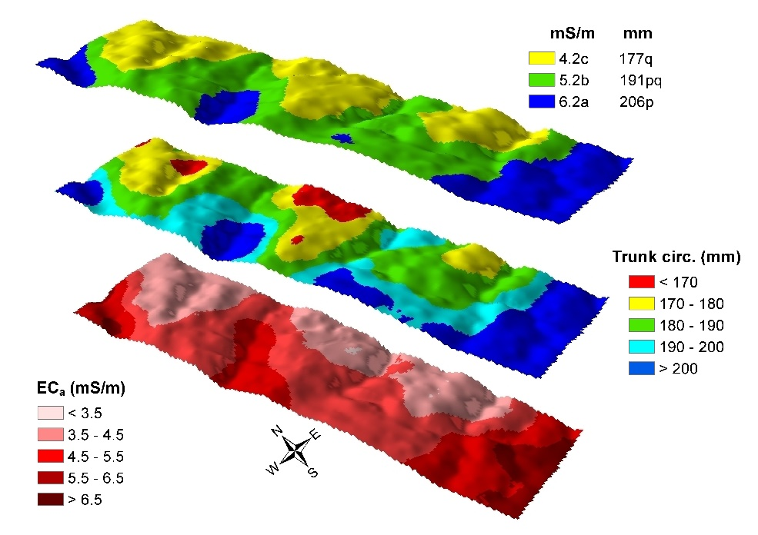

**Figure 2.** Variation in apparent electrical soil conductivity (ECa), vine vigour, expressed in terms of trunk circumference and elevation. The top map shows the results of clustering the ECa and trunk circumference maps using *k*-means; cluster means marked by different letters are significantly different (*P*<0.05). Data of Bramley et al. (2011b).

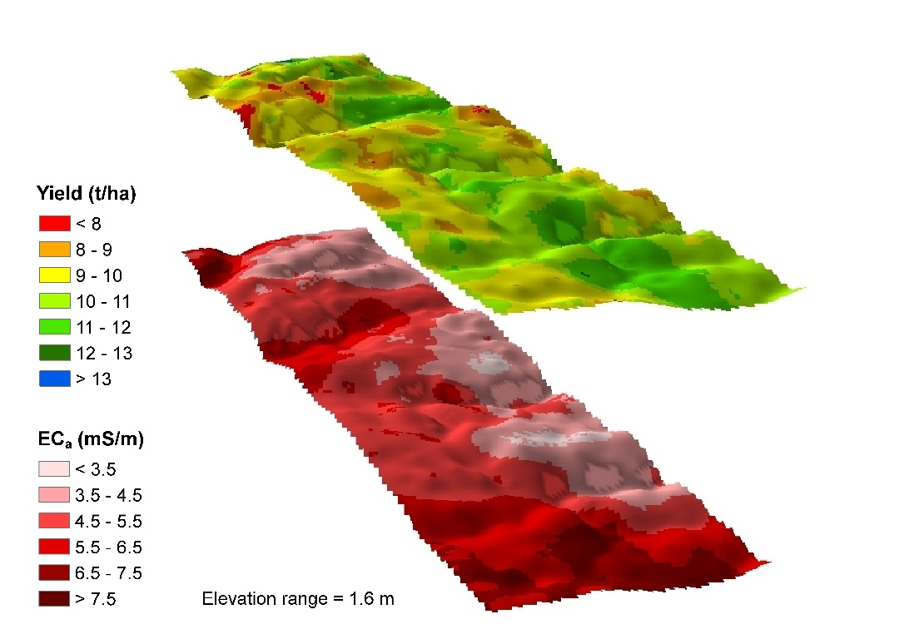

**Figure 3.** Yield variation in 2006 in ‘Squire D’ was unrelated to apparent electrical soil conductivity (ECa), vine vigour (not shown) and elevation. The yield map shown here derived from a ‘Farmscan’ yield monitor fitted to the discharge chute of the grape harvester. Data of Bramley et al. (2011b).

led to a ‘smoothing out’ of variation in grape yield. However, only a single year of yield data were available to the Bramley et al. (2011b) study.

Seasonal differences in grape yield present significant challenges to both grapegrowers and winemakers (Trought et al., 2018 and references therein), which is a major reason for the recent research focus placed on yield estimation (Dunn and Martin, 2003; Diago et al., 2014, 2015; Nuske et al., 2014; Herrero-Huerta et al., 2015; Liu et al., 2017). Understanding the sources of variation in yield and yield components will help improve the methods and accuracy of pre-harvest yield estimates. Spatial variability in grape yield can make yield estimation complex (Bramley and Hamilton, 2004; Proffitt et al., 2006), although prior knowledge of this variability and especially its temporal stability can assist in appropriate targeted sampling. This latter point is also relevant to deployment of sensors which may contribute to, or perform, the yield estimation. On the assumption that both industry access to, and deployment of yield estimation sensing technology are unlikely to be ubiquitous, it is of interest to know whether spatial variation in yield and vine vigour in Marlborough is stable in time so that the deployment of such technology can be appropriately targeted. Thus, a yield estimating technology might sensibly be deployed in at least some areas of known characteristic yield performance (i.e. relatively low, average or high yielding) so that, knowing the proportional area of these ‘zones’ of characteristic performance, a more robust yield estimate might be obtained than by using a conventional approach based on random sampling. Note that random sampling is likely impacted both by spatial variability, the adequacy of sample number and human bias; that is, it may not be random. Given that yield monitors are not greatly used in Marlborough, but that remotely sensed imagery is now quite accessible in New Zealand, it is also of interest to know whether variation in vine vigour can be used as a surrogate for variation in yield; the previous work of Bramley et al. (2011b) is equivocal on the latter point, whilst additional data would lend weight to suggestion that variation in vine vigour in cane pruned vineyards is temporally stable, as seems to be the case in spur pruned blocks. Using additional data from the same site, but which were not available for the Bramley et al. (2011b) study, the present work explores these issues.

**Methods and Materials**

A detailed description of the study site was given by Trought et al. (2008); it can be considered typical of commercial Sauvignon Blanc vineyards in Marlborough, *viz*. vines cane pruned to a vertical shoot positioning system with row and vine spacings of 2.4 and 1.8 m, and drip irrigation applied at 0.8-1.7 ML/ha/y depending on seasonal conditions. Foliage wires are used to maintain a narrow canopy approximately 0.4 m wide and the 1.6 m tall vines are typically trimmed three times during the growing season to maintain these dimensions. Pest and disease management is achieved by following NZ Sustainable Winegrowing practice ([www.nzwine.com/swnz/](http://www.nzwine.com/swnz/)).

*Remote and proximally sensed Imagery*

In addition to the remote and proximally sensed imagery that was available to the Bramley et al. (2011b) study (Figure 1), archival remotely sensed imagery was also available from the same commercial provider for the season ending with vintage in 2009. In 2017, further imagery was purchased from the same provider; all images were acquired at dates which approximated veraison in each year. The 2006, 2007 and 2009 imagery was acquired at an on-ground resolution of 50 cm whilst in 2017, the imagery was acquired at 40 cm resolution. However, and as described by Bramley et al. (2011b), all images were smoothed to the same 2 m raster grid as used in that previous work, with this grid defined by the block boundaries which had been surveyed using a differentially corrected global positioning system (dGPS; accurate to within +/- < 1 m).

*Vine sampling*

In the present work, vines planted in 1994 were pruned to retain four canes (the conventional management at that time) up to the start of the experiment in August 2004. Data were collected in the seasons culminating with vintage 2005, 2006, 2007 and 2008 and are considered in two parts. One half derives from the vines used by Trought and Bramley (2011) in studying spatial variability in juice quality; during the experiment these were pruned to a two-cane system and were located in six ‘plots’, each of four adjacent vines, such that each plot constituted the row length between two trellis support posts within a single row, otherwise known as a ‘bay’. Thus, data from a total of 24 of these two cane vines were available. The six plots were located within four rows and were chosen to give a range of vine sizes (Trought et al., 2008), with vine size classified on the basis of trunk circumference within each row.

The other half of the available data derived from a further four rows, and pruned to retain four canes.. Again, there were six plots located on the basis of vine size. The total of eight rows used in this study were those in which each vine had trunk circumference measured (Trought et al., 2008), and thus, were the basis for the map of trunk circumference (Figure 1) as described by Bramley et al. (2011b). Other than the pruning of the two different sets of four rows, all other aspects of vineyard management and vine sampling were the same for the two sets of vines.

Vine phenology (bud burst, flowering, berry size and composition), yield, yield components (bunch number per vine and berry mass) and pruning mass were collected in the period between flowering and harvest in each of the 2005-2008 seasons. Bunch mass was estimated using yield and bunch number data, and berry number per bunch using berry mass at harvest and bunch mass. Here, we confine the analysis to vine yield, bunch numbers, berry mass and in 2005-2007 (but not 2008), pruning mass. Shoot numbers and diameters were also recorded pre-pruning. The fresh weight of the current and previous season’s wood recorded separately and shoot diameters recorded across the widest section mid-way between nodes two and three. The diameters were divided into small (<6mm), medium (6 to 11mm) and large (>11mm). Average shoot weight was determined from the weight of the current season’s pruned growth and shoot number and scaled to reflect the actual number of shoots per vine.

In addition to the trunk circumference measurements made in 2004 (Trought et al., 2008; Bramley et al., 2011b), the trunk circumference of the 48 two or four cane pruned vines sampled in 2005-2008 was re-measured in 2018. Measurements were made 10 cm above the graft union and 10 cm below the head of the vine, with trunk circumference expressed as the mean of these two measurements and converted to cross sectional area.

*Statistical and spatial analysis*

All statistical analysis was done in JMP (v. 11.0, SAS Institute Inc, Cary, NC, USA) including *k*-means clustering of map layers. Bramley et al. (2011b) provide details of map production; map display and the export of data from map layers for further analysis was done using the ArcGIS software suite (v10.4.1; ESRI, Redlands, CA, USA). The data derived from the vine sampling were analysed using standard Fisherian methods such as one-way Analysis of Variance and Pearson’s correlation, etc… For some analyses, the data collected in any given season were normalised (mean of zero, standard deviation of one) to remove seasonal effects from the analysis.

**Results and Discussion**

*Variation in vine vigour*

Patterns of spatial variation in vine vigour as measured close to véraison using remotely sensed imagery, were seen to be stable over a 12 year period (Figure 4). Thus, when mean values of PCD were calculated from the 2006, 2007, 2009 and 2017 imagery, the result showed the same characteristic pattern of variation as can be seen in the imagery for any individual year. This pattern was also evident when the data from these four years were clustered into either three or five ‘zones’ using *k*-means, and is also very similar to that seen in 2007 when PCD was measured from the side using a proximal sensor (Figure 4), and in the map of trunk circumference measured in 2004 (Figure 1). Similarly, close correlations were observed between the pruning weights determined in each season (2005-2007; Table 1). Thus, when the pruning weight data, normalised on a per season basis, were regressed against PCD values extracted from the 2007 Crop Circle image (Figures 1 and 4), the instantaneous measure of vine vigour provided by this proximal sensor scanning from the side, was seen to be a reasonable predictor of vine vigour in each of three seasons (2005-2007) and to match the classification of vine size based on trunk circumference (Figure 5; Trought et al., 2008).

The re-measurement of trunk circumference in 2018 enabled examination of its relationship with the 2004 measurement, and also enabled vine vigour to be expressed in terms of an increase in trunk cross-sectional area over the intervening 15 years. Vines with the lowest cross sectional area in 2004 (Trought et al., 2008) were also those which showed the lowest increase in area between 2004 and 2018 (Figure 6). In other words, vines with the lowest trunk cross sectional area (Figure 6) are also those with the lowest photosynthetically active canopy biomass (i.e. canopy vigour; Figures 1, 4) and so have the lowest rate of growth in trunk cross sectional area (Figure 6). Collectively, these observations lend considerable weight to the conclusion that patterns of variation in vine vigour are stable in time.



**Figure 6:** Change in trunk cross-sectional area between August 2004 and May 2018. The classification of vine size is that of Trought et al. (2008), with ● XS denotes ‘extra small’, ● S ‘small’, ● M ‘medium’, ● L ‘large’ and ● XL ‘extra large’.

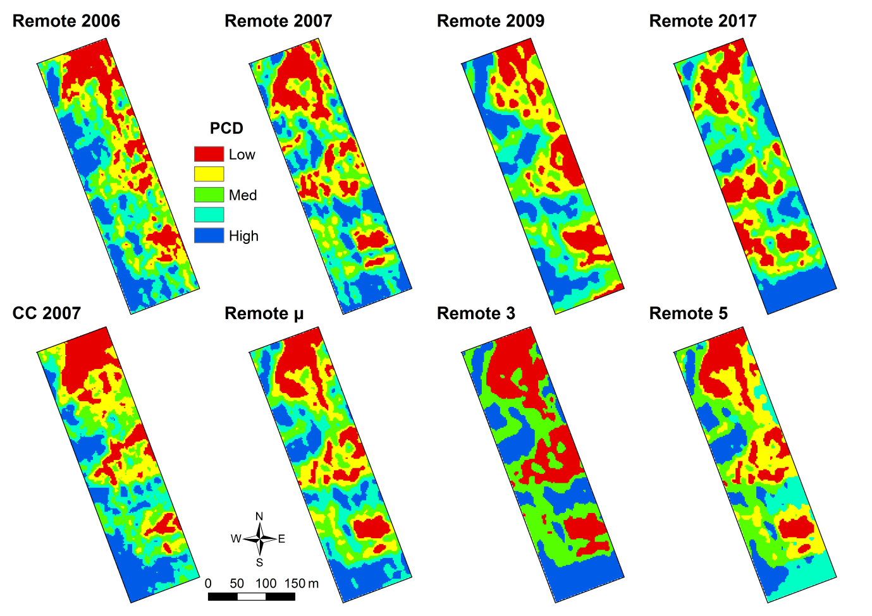

**Figure 4.** Variation in vine vigour in a 5.9 ha Marlborough Sauvignon Blanc vineyard as measured using remote and proximal sensing of PCD at veraison over an 11 year period. Remotely sensed imagery (top row of maps) was acquired using airborne digital multispectral video, whilst the proximal image (bottom left) was obtained from a Crop Circle™ sensor (CC). The other maps in the bottom row show the results of analysis undertaken using the remotely sensed imagery only – the mean (µ) of the four images in the top row, and the results of clustering these using *k*-means (three and five cluster solutions are shown). The legends to all maps other than the cluster maps are classified into 20th percentiles. For the cluster maps, the colours are matched to the other maps based on the cluster means.

**Table 1.** Correlations between the weight of new wood produced over 3 seasons (2005-2007) and trunk circumference measured in 2004.

|  |  |  |  |
| --- | --- | --- | --- |
|  | **2005** | **2006** | **2007** |
|  | | | |
|  | Two-cane pruned vines | | |
| 2006 New cane weight | 0.75*** |  |  |
| 2007 New cane weight | 0.71*** | 0.84*** |  |
| Trunk circumference in 2004 | 0.69*** | 0.87*** | 0.79*** |
|  | | | |
|  | Four-cane pruned vines | | |
| 2006 New cane weight | 0.76*** |  |  |
| 2007 New cane weight | 0.87*** | 0.80*** |  |
| Trunk circumference in 2004 | 0.81*** | 0.81*** | 0.84*** |

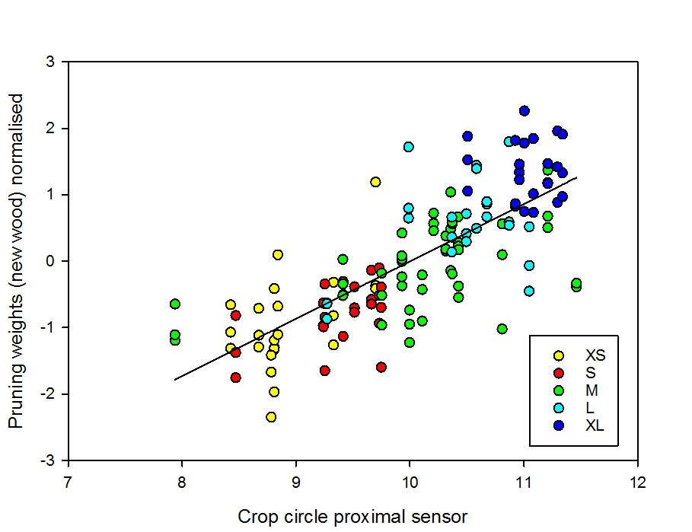

**Figure 5.** Relationship between pruning weight (new wood) over three seasons (2005-2007) and PCD measured in March 2007 using the Crop Circle proximal sensor.

Overall, we conclude that patterns of variation in vine vigour / vegetative growth are stable in time. Given the observation that vine vigour in Marlborough Sauvignon impacts on fruit composition and that, in turn, its variation impacts on juice quality and wine style (Trought et al., 2008; Trought and Bramley, 2011), the knowledge that variation in vine vigour is temporally stable has important implications for strategies such as selective harvesting (Trought and Bramley, 2011).

*Variation in yield*

Plot to plot differences in yield and yield components were observed despite the consistency in node number retained after pruning (Table **). Over the four years of the trial, 2-cane pruned vines produced a yield 63% of the 4-cane treatment, reflecting differences in bunch number. 2- and 4-cane pruned vines had similar berry mass, bunch mass and berry number per bunch, on average within 3% of each other on average over the four seasons. Berry mass exhibited a similar and the smallest coefficient of variation (CV) when different seasons and pruning treatments are considered. Berry number per bunch and bunch mass had a greater CV and bunch number per vine the largest of the four components measured.

|  |  |  |  |  |  |  |  |  |
| --- | --- | --- | --- | --- | --- | --- | --- | --- |
|  | **2-cane pruned vines** | | | | **4-cane pruned vines** | | | |
|  | **2005** | **2006** | **2007** | **2008** | **2005** | **2006** | **2007** | **2008** |
| **Yield per vine (kg)** | 3.81 | 3.07 | 3.46 | 4.40 | 6.87 | 4.37 | 5.37 | 6.91 |
| (25.63) | (18.40) | (21.22) | (21.57) | (18.64) | (15.71) | (19.41) | (12.40) |
| **Bunches per vine** | 39.55 | 35.15 | 42.57 | 36.46 | 69.36 | 52.91 | 71.77 | 57.65 |
|  | (17.47) | (13.60) | (14.54) | (13.92) | (20.57) | (12.03) | (9.84) | (7.74) |
| **Bunch mass (g)** | 95.73 | 87.11 | 81.09 | 119.56 | 96.58 | 82.36 | 74.47 | 119.80 |
|  | (14.70) | (11.22) | (13.79) | (10.45) | (13.39) | (7.95) | (13.56) | (8.53) |
| **Berry mass (g)** | 1.85 | 1.90 | 1.88 | 2.11 | 1.86 | 1.80 | 1.87 | 2.08 |
|  | (5.03) | (6.69) | (5.61) | (4.46) | (4.21) | (5.50) | (5.83) | (4.11) |
| **Berry no. per bunch** | 52.10 | 46.00 | 43.42 | 57.42 | 51.92 | 45.95 | 39.90 | 57.59 |
| (16.75) | (10.94) | (12.82) | (12.23) | (13.88) | (8.56) | (13.45) | (9.07) |

Values are the mean of 24 2-cane and 4-cane pruned plots and coefficient of variation (in brackets) across all vine sizes

In contrast to vine vigour, and noting that analysis of yield and yield component variation was confined to the 48 sampled bays, yields and the yield components of individual plots did not appear to be stable between years (Figure 7); despite retaining the same node number each year, individual bays that were comparatively low yielding in one year could be higher yielding in other years, with no obvious consistent trend from year to year. This result contrasts with previous Australian work which strongly suggests that patterns of variation in yield are temporally stable in spur pruned vineyards (Bramley and Hamilton, 2004, 2007; Bramley et al., 2011a). Furthermore, and consistent with the observations of Bramley et al. (2011b), differences in yield between the different vine size classes of Trought et al. (2008) were generally not significant (*P*<0.05). Exceptions were in 2006 when the yields of ‘medium’ vines were and ‘small’ vines were. Likewise, there was no significant (*P*>0.05) correlation between yield in any of 2005-2008 and PCD as measured using the Crop Circle sensor (Figures 1 and 4). Given the consistency of variation in vine vigour over 15 years (Figures 4-6), we therefore infer that yield and vigour are not related in this cane pruned Marlborough Sauvignon Blanc vineyard. As indicated, this finding is in marked contrast to the relationship between yield and vine vigour commonly seen in spur pruned Australian vineyards (e.g. Bramley and Hamilton, 2007; Bramley 2010; Bramley et al., 2011a).

a.

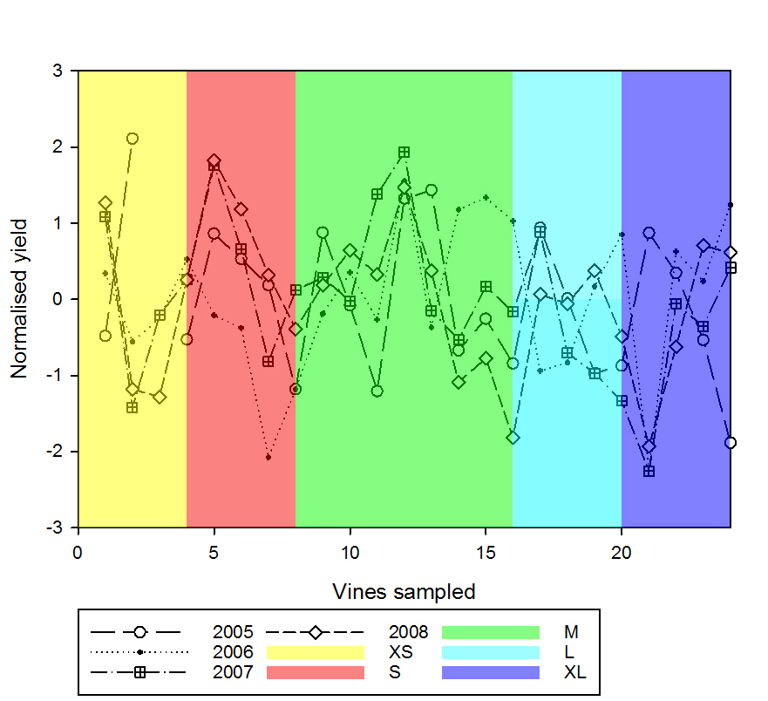

b.

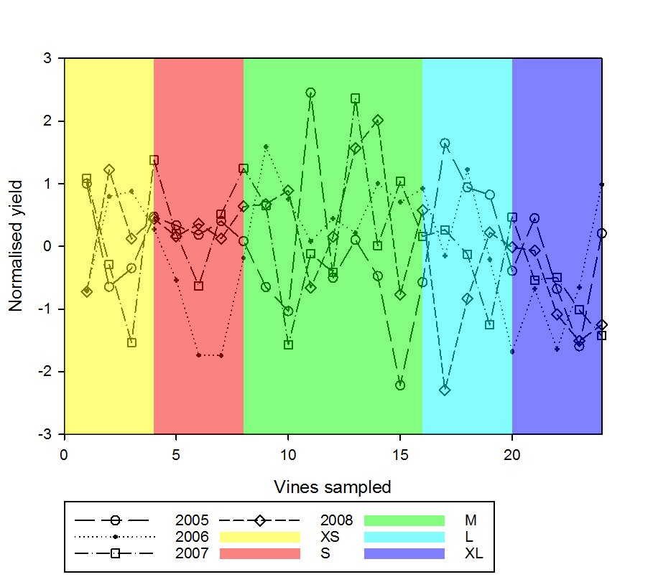

**Figure 7.** Variation in yield per vine over four seasons (2005-2008) in vines pruned to either (a) two or (b) four canes. Note that the data have been normalised on a per season basis. The classification of vine size is that of Trought et al. (2008), with XS denotes ‘extra small’, S ‘small’, M ‘medium’, L ‘large’ and XL ‘extra large’.

**Figure 8.** Variation in yield per vine over three seasons (2005-2007) in two cane pruned vines. Note that the data have been normalised on a per season basis.

Figure 8: Variation in yield components of 2- and 4-cane pruned vines over four seasons (2005 to 2008)

When the analysis was focussed on the components of yield, similar results were obtained. Thus, bunch numbers, which have been noted to correlate closely with yield (Dunn and Martin, 2003; Trought et al., 2018), did not show consistent variation from year to year (Figure 8) and were not correlated (*P*>0.05) with any of the indices of vine vigour.

Somewhat surprisingly, measures of berry weight made at approximately weekly intervals during the veraison to harvest period were generally not well correlated from one sampling event to the next. Similarly, berry weight at veraison was not a good predictor (*P*>0.05) of berry weight at harvest. In other experiments, sequential measurements of individual berry diameters from 14 February (véraison) to harvest on 28 March have demonstrated a strong correlation (R2 0.850, n=120) (Neal pers. comm.) suggesting that the lack of correlation between the weekly berry weight sample is a reflection of the difficulties associated with collecting a representative berry sample. The results in this experiment are consistent with Bramley et al. (2011a) from the Australian Murray Valley, berry weight at harvest was not correlated with indices of either vine vigour or yield, although berry weight close to veraison was negatively correlated with indices of vigour.

In summary, and in contrast to the result for indices of vine vigour, based on data available from the same 48 vines over four seasons, yield variation does not appear to be either stable in time or related to retained node number (2- versus 4-cane pruned vines) or differences in vine vigour. One possible implication is that decisions at pruning are a significant source of vine to vine variation. Cane selection and the history of the development of that cane, is having a disproportional influence on yield and yield components. For example, selecting a cane with a large cross-sectional area may increase the productivity of all of the shoots arising from that cane. This may represent 50% of all of the shoots on a 2-cane pruned vine. Similarly, a shoot that has developed in the shade of the canopy will experience reduced light on the buds, with the consequence of lower bud fruitfulness (Buttrose 1969). Inter-seasonal differences in cane selection were apparent in (Eltom et al. 2014), where the distribution of the cross-sectional area of canes retained after the warmer 2010-11 growing season (for the 2011-12 season) were greater than those retained after the 2009-10 season. As a consequence, the differences in yield between the season was the product of temperature at initiation and the size of the shoot retained after pruning.



**Figure 8.** Effect of grapevine cane cross-sectional area on the average number of inflorescences per shoot along a cane for the 2011/12 season (**○,○,○**) and for the 2012/13 season (**○,○,○**). Vines were pruned to two canes (**○,○**), four canes (**○**,**○**) or spur-pruned (**○**,**○**). Cane cross-sectional area was calculated between basal buds two and three, and was grouped in 10 mm2 increments. Average number of inflorescences along the cane was calculated by adding the number of inflorescences for each shoot along a cane together, then dividing by the number of shoots along the cane. Frequency = number of measurements in each size grouping. (Figure 2: Eltom et al. 2014).

In practice, cane selection by the pruner may, or may not reflect the overall shoot size of the vine pre-pruning. Bramley et al. (2011) suggested that the lack of a soil texture response in cane-pruned Marlborough Sauvignon blanc vineyards may reflect the selection of similar cane size throughout the vineyard, irrespective of the overall vigour of the vine.

*Implications for sensor-based yield estimation in Marlborough*

Stability in patterns of variation in vineyard attributes have potential to guide targeted sampling. The present data suggest that in the case of sampling to guide yield estimation, whether done using sensor technologies or more traditional approaches, yield and the components there in, variation is not temporally stable which leads to the conclusion that a random sampling approach may suffice. However, variation in vine vigour shows a clear stability in its patterns of spatial variation and whilst these may not seem relevant given the lack of association between vine vigour and yield in this cane pruned Marlborough Sauvignon Blanc vineyard, there is a compelling reason why knowledge of vigour variation might make an important contribution to the yield estimation problem. As Trought et al. (2008) and Trought and Bramley (2011) have demonstrated, variation in vine vigour may impact markedly on grape composition and the perception of ‘juice quality’. Given that the objective of the Marlborough wine industry is not to make a single production, but to engage in the product differentiation which leads to bottle prices of Marlborough Sauvignon Blanc varying from between c. NZ$8/bottle to more than NZ$30/bottle, the key yield estimation question is not one of knowing the total tonnage of fruit, but rather is one of knowing the tonnage of fruit that is suitable for a particular product stream. As Trought and Bramley (2011) have also highlighted, an ability to predict the date on which this product-specific fruit should be harvested is also potentially highly valuable. So we would argue that factoring knowledge of vine vigour into the yield estimation problem is both worthwhile and necessary. We therefore suggest a targeted sampling program/sensor deployment based on variation in vine vigour, noting that, conveniently, the lack of temporal stability or spatial structure in patterns of variation in vine vigour means that a random sampling/sensing approach within a ‘vigour zone’ would be appropriate.

Recent progress in optically based sensor approaches to yield estimation (eg. Nuske et al., 2014; Diago et al., 2015; Liu et al., 2017) may provide an alternative and simpler approach to early season yield estimation. Problems posed by bunch occlusion by leaves and other bunches presents a significant challenge to bunch number/mass estimation once the canopy has developed post-flowering. The relationship between cane diameter and bunch number per shoot and bunch structure (Eltom et al. 2014, Trought et al. 2017) suggests that an early season estimate of variation within the vineyard of potential yield may be achieved using post-budburst measurement of pruned vines. This knowledge can be used when selecting sample vines for post-flowering yield assessment (e.g. destructive bunch count and mass measurement), enabling viticulturists to accurately assess the contribution of vines to the overall vineyard yield potential.

This early season prediction, when coupled to the knowledge that Sauvignon blanc bunch mass at veraison is approximately 50% of bunch mass at harvest (Trought and Yang 2018) (Trought unpublished data) provides an opportunity for accurate early season yield estimation. To obtain a reliable estimate, bunch and vine mass data collected post-flowering has to be adjusted to take into account inter-seasonal differences in phenology. For example, bunches on a particular date will be at a different proportion of final mass in an early- versus a late-flowering season, and estimates need to be adjusted accordingly. Flowering and véraison dates may be predicted as a function of GFV degree days (Parker et al. 2011) and using this model to predict the key phenological dates on a seasonal, regional and sub-regional basis enables the estimates to be adjusted.

**Conclusions**

Differences in soil texture were reflected in annual vegetative growth (measured from seasonal pruning mass) and accumulated growth over 14 years (reflected in the increase in trunk cross sectional area). In contrast, there are marked differences in the stability of yield and the components (bunch number per vine, berry number per bunch and berry weight) that contribute to vine yield. The stability of these components do not appear to be associated with soil texture differences in a cane pruned Sauvignon blanc vineyard or the number of nodes retained after pruning.

**Acknowledgments**

This work has been jointly funded by CSIRO, New Zealand Plant and Food Research (NZPFR) and the New Zealand Ministry of Business Innovation and Employment (MBIE) through an ‘Endeavour grant’ provided to Lincoln Agritech Ltd (‘A sensor and model-based analyser for blockscale grape yield prediction’). However, it was made possible by the efforts of a large number of NZPFR staff in collecting the field data over several years. The assistance of Pernod Ricard in the latter and with respect to vineyard access is also greatly appreciated.

**References**

Bramley, RGV. 2010. Precision Viticulture: Managing vineyard variability for improved quality outcomes. Chapter 12 in: Reynolds, A.G. (Ed) Managing Wine Quality. Volume 1. Viticulture and wine quality. Woodhead Publishing: UK. pp. 445-480.

Bramley RGV, Hamilton RP. 2004. Understanding variability in winegrape production systems. 1. Within vineyard variation in yield over several vintages. Australian Journal of Grape and Wine Research 10, 32-45.

Bramley RGV, Hamilton RP. 2007. Terroir and Precision Viticulture: Are they compatible? Journal international des Sciences de la Vigne et du Vin 41: 1-8.

Bramley RGV, Ouzman J, Boss PK. 2011a. Variation in vine vigour, grape yield and vineyard soils and topography as indicators of variation in the chemical composition of grapes, wine and wine sensory attributes. Australian Journal of Grape and Wine Research 17, 217-229.

Bramley RGV, Trought MCT, Praat J-P. 2011b. Vineyard variability in Marlborough, New Zealand: Characterising variation in vineyard performance and options for the implementation of Precision Viticulture. Australian Journal of Grape and Wine Research 17, 72-78.

Buttrose, M.S. (1969) Fruitfulness in grapevines: Effects of light intensity and temperature. Botanical Gazette **130**, 166 - 173.

Diago MP, Sanz-Garcia A, Millan B, Blasco J, Tardaguila, J. 2014. Assessment of flower number per inflorescence in grapevine by image analysis under field conditions. Journal of the Science of Food and Agriculture 94, 1981–1987.

Diago MP, Tardaguila J, Aleixos N, Millan B, Prats-Montalban J. M. Cubero S., Blasco J. 2015. Assessment of cluster yield components by image analysis. Journal of the Science of Food and Agriculture 95, 1274–1282.

Dunn GM, Martin SR. 2003. The current status of crop forecasting in the Australian wine industry. In: Bell SM, de Garis KA, Dundon CG, Hamilton RP, Partridge SR, Wall GS. (Eds). Grapegrowing at the edge. Proceedings of the ASVO seminar series, Tanunda, 10-11 July, 2003. Australian Society of Viticulture and Oenology, Adelaide.

Eltom, M., Winefield, C.S. and Trought, M.C.T. (2014) Effect of pruning system, cane size and season on inflorescence primordia initiation and inflorescence architecture of Vitis vinifera L. Sauvignon Blanc. Australian Journal of Grape and Wine Research **20**, 459-464.

Herrero-Huerta M, González-Aguilera D, Rodriguez-Gonzalvez P, Hernández-López D. 2015. Vineyard yield estimation by automatic 3d bunch modelling in field conditions. Computers and electronics in agriculture 110, 17–26.

Lamb DW, Weedon MM, Bramley RGV. 2004. Using remote sensing to map grape phenolics and colour in a cabernet sauvignon vineyard - the impact of image resolution and vine phenology. Australian Journal of Grape and Wine Research 10, 46-54.

Liu S, Cossell S, Tang JL, Dunn G, Whitty M. 2017. A computer vision system for early stage grape yield estimation based on shoot detection. Computers and Electronics in Agriculture 137, 88-101.

Mills, T. (2006) Relations among geology, soil type and Sauvignon blanc vineyard variation in Marlborough, New Zealand. The University of Auckland, The University of Auckland, 260 pp.

Nuske S, Wilshusen K, Achar S, Yoder L, Singh S. 2014. Automated Visual Yield Estimation in Vineyards. Journal of Field Robotics 31, 837-860.

Parker, A.K., Garcia de Cortazar-Atauri, I., van Leeuwen, C. and Chuine, I. (2011) General phenological model to characterise the timing of flowering and veraison of *Vitis vinifera* L. Australian Journal of Grape and Wine Research **17**, 206-216.

Proffitt T, Bramley R, Lamb D, Winter E. 2006. Precision Viticulture – A new era in vineyard management and wine production. Winetitles, Adelaide.

Rae SN, Tozer CG. 1990. Land and soil resources. Nelson-Marlborough Regional Council, Blenheim.

Trought MCT, Bramley RGV. 2011. Vineyard variability in Marlborough, New Zealand: Characterising spatial and temporal changes in fruit composition and juice quality in the vineyard. Australian Journal of Grape and Wine Research 17, 79-89.

Trought MCT, Dixon R, Mills T, Greven M, Agnew R, Mauk JL, Praat JP. 2008. The impact of differences in soil texture within a vineyard on vine vigour, vine earliness and juice composition. Journal international des Sciences de la Vigne et du Vin 42, 67–72.

Trought MCT, Parker AK, Zhu J. 2018. Yield components of grapevine: a review. Report to Lincoln Agritech.

Trought, M. and Yang, L. (2018) Grape yield analyser project — quarterly report: January to April 2018. (Plant and Food Research Ltd.).